Web Fundamentals- Assessment
- Student Registration
<!DOCTYPE html>
<html lang="en">
<head>
<meta charset="UTF-8">
<meta name="viewport" content="width=device-width, initial-scale=1.0">
<title>Student Registration</title>
<link rel="stylesheet" href="style.css">
</head>
<body>
<h1>Student Registration Form</h1>
<p>Fill all the fields for registration.</p>

<form id="registrationForm">
<label for="name">Full Name:</label>
<input type="text" id="name">
<span id="nameError" class="error-text"></span>

<label for="email">Email:</label>
<input type="email" id="email">
<span id="emailError" class="error-text"></span>

<label for="dob">Date of Birth:</label>
<input type="date" id="dob">
<span id="dobError" class="error-text"></span>

<label>Gender:</label>
<div class="radio-group">
<input type="radio" id="male" name="gender" value="male">
<label for="male">Male</label>
<input type="radio" id="female" name="gender" value="female">
<label for="female">Female</label>
<input type="radio" id="other" name="gender" value="other">
<label for="other">Other</label>
</div>

<label>Languages Known:</label>
<div class="checkbox-group">
<input type="checkbox" name="language" value="english">English
<input type="checkbox" name="language" value="tamil">Tamil
<input type="checkbox" name="language" value="malayalam">Malayalam
</div>

<label for="course">Course:</label>
<select id="course">
<option value="">select course</option>
<option value="be">B.E</option>
<option value="me">M.E</option>
<option value="mba">MBA</option>
<option value="mca">MCA</option>
</select>
<span id="courseError" class="error-text"></span>

<button type="submit">Submit</button>
</form>

<h3>Campus Facilities</h3>
<ul>
<li>large Auditorium</li>
<li>WiFi connection</li>
<li>Library</li>
</ul>

<footer>
Sowndariya K - 2026
</footer>
<script src="validate.js"></script>
</body>
</html>

Style.css
body {
background-color: #f0f4f8;
font-family: Arial, sans-serif;
margin: 0;
}

h1 {
color: #1F3864;
text-align: center;
font-size: 2rem;
border-bottom: 3px solid #1F3864;
padding-bottom: 10px;
}

p,footer{
text-align: center;
}

form {
display: flex;
flex-direction: column;
max-width: 500px;
margin: 0 auto;
padding: 24px;
background: #ffffff;
box-shadow: 0 2px 8px rgba(0,0,0,0.1);
}
button{
background-color: #1F3864;
color: #ffffff;
}

input, select {
width: 100%;
padding: 8px;
margin-bottom: 12px;
border: 1px solid #cccccc;
border-radius: 4px;
box-sizing: border-box;
}

input[type="radio"], input[type="checkbox"] {
width: auto;
}

.error-text {
color: red;
font-size: 0.85rem;
margin-top: -10px;
margin-bottom: 10px;
}

@media (max-width: 600px) {
form { max-width: 100%; }
body { padding: 12px; }
}

Validate.js
document.getElementById('registrationForm').addEventListener('submit', function(event) {
let isValid=true;

// full name
const name=document.getElementById('name').value;
if (name.trim()==='') {
document.getElementById('nameError').textContent='Full Name is required.';
isValid = false;
}

// email
const email=document.getElementById('email').value;
if (!email.includes('@') || !email.endsWith('.com')) {
document.getElementById('emailError').textContent='Invalid email format. Must contain @ and end with .com';
isValid = false;
}

// date of birth
const dobValue=document.getElementById('dob').value;
if (!dobValue){
document.getElementById('dobError').textContent='Date of Birth is required.';
isValid=false;
}
else {
const birthDate=new Date(dobValue);
const today=new Date();
let age=today.getFullYear() - birthDate.getFullYear();
const m=today.getMonth()-birthDate.getMonth();
if (m<0 || (m===0 && today.getDate()<birthDate.getDate())) {
age--;
}
//age less than 17
if (age<17) {
document.getElementById('dobError').textContent='age must be at least 17 years old.';
isValid = false;
}
}

// course
const course=document.getElementById('course').value;
if (course==='') {
document.getElementById('courseError').textContent='Please select a course.';
isValid=false;
}

if (!isValid) {
event.preventDefault();
}
});

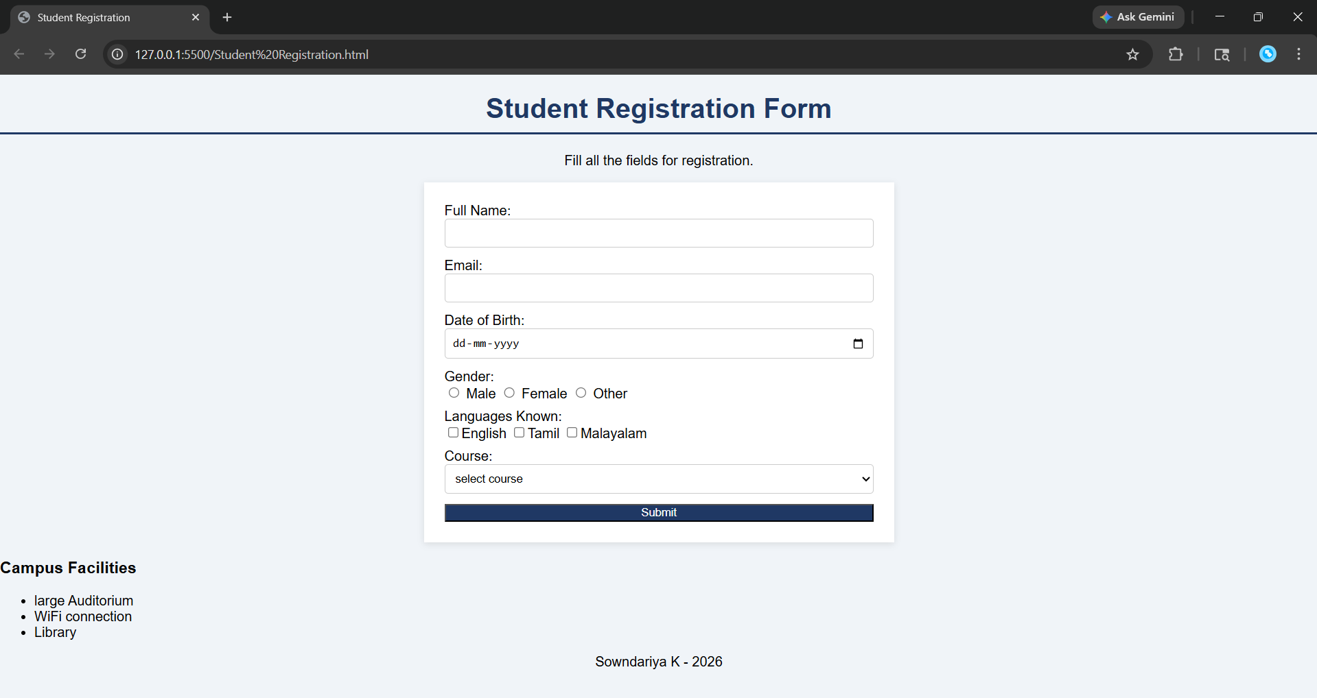

2. ToDo List
<!DOCTYPE html>
<html lang="en">
<head>
<meta charset="UTF-8">
<title>To-Do List application</title>
<style>
body{
font-family: sans-serif;
padding: 20px;
text-align: center;
}
ul{
list-style: none;
padding: 0;
}

li{
text-align: center;
margin-bottom: 10px;
background: #eeeeee;
padding: 10px;
display: flex;
justify-content: space-between;
max-width: 300px;
margin: 0 auto;
}

button.delete-btn{
background: red;
color: white;
border:none;
cursor: pointer;
}
</style>
</head>
<body>
<h2>To-Do List</h2>
<input type="text" id="taskInput" placeholder="Enter task">
<button onclick="addTask()">Add Task</button>
<ul id="taskList"></ul>
<script>
function addTask() {
const input=document.getElementById('taskInput');
const taskText=input.value.trim();
if (taskText==="") {
alert("Please enter a task");
return;
}
const ul=document.getElementById('taskList');
const li=document.createElement('li');
const textNode=document.createTextNode(taskText);
li.appendChild(textNode);

const delBtn=document.createElement('button');
delBtn.textContent='Delete';
delBtn.className='delete-btn';
delBtn.onclick=function() {
ul.removeChild(li);
};

li.appendChild(delBtn);
ul.appendChild(li);
input.value="";
}
</script>
</body>
</html>
